October 14, 2024
Kirk Soileau, C.E.O.
Natchitoches Regional Medical Center
501 Keyser Avenue
Natchitoches, La. 71457

Dear Mr. Soileau,
It was a pleasure to speak to you at the hospital dinner on Thursday about the chaplaincy position opening at NRMC. I am encouraged to hear your enthusiasm about expanding the spiritual care department for patients at the hospital.
I appreciate the importance that faith plays in your own life and how that influences your work as a C.E.O. It is my prayer that in the following ministry resume, you will catch a glimpse of my heart and calling towards serving as a hospital chaplain in our community.
Thank you for your time and consideration. If you have further questions or need additional information, please do not hesitate to contact me. I look forward to hearing from you.

Sincerely,

Wendy Perego
228 Riverside Lane
Natchez, Louisiana 71456

(318) 308-3308
wendyperego@icloud.com

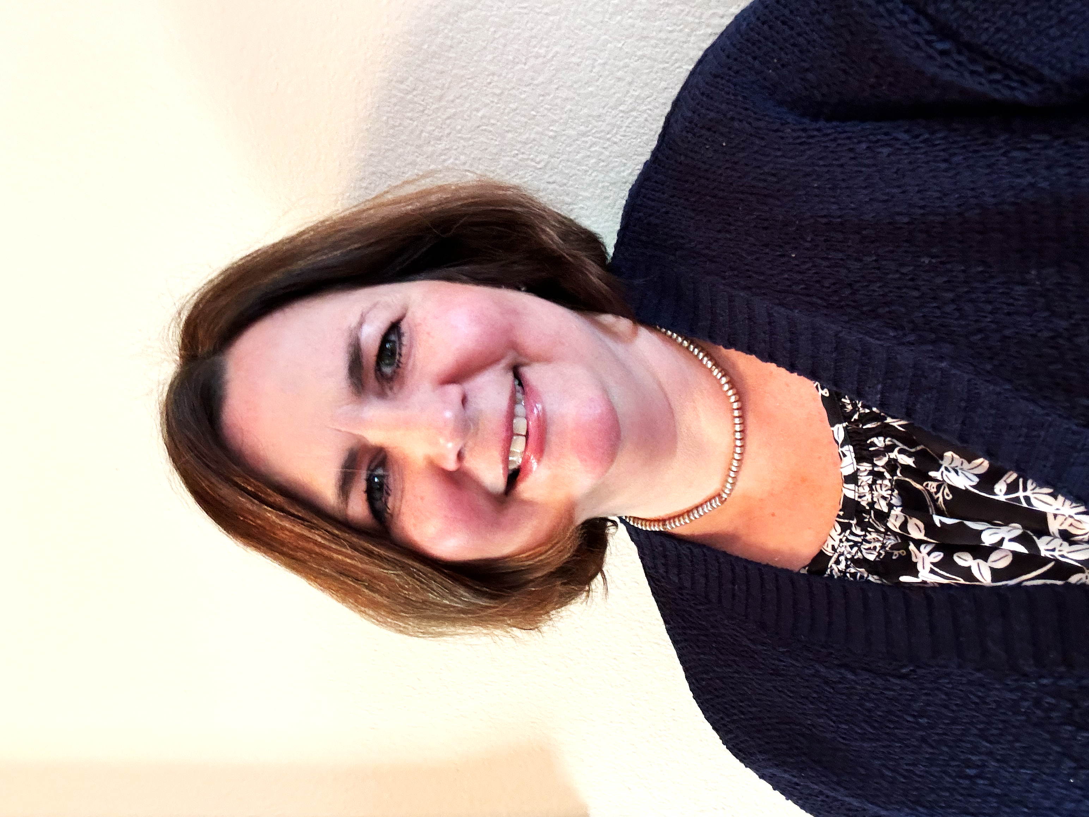
Wendy Perego

228 Riverside Lane Natchez, La. 71456
(318)308-3308 | wendyperego@icloud.com

Ministry Philosophy
Chaplaincy ministry is a surprise joy that the Lord opened in my heart later in life. I have felt great honor in sharing Christ’s compassion with the hurting and struggling. Regardless of religious background, people are most receptive to spiritual care in their time of crisis and uncertainty. I enjoy meeting them where they are and showing them that they are valuable to God, they are heard, and they are not alone.

Personal Summary
I was born in New Orleans, Louisiana and grew up with two brothers in nearby Mandeville. My parents are Barry and Liz Haindel who just celebrated 40 years in full time ministry.
In the fifth grade, a Bible teacher shared that some people believe they are Christians, but they are not. This scared me to death. I went home and prayed like I have never prayed before, desperately begging God to assure me that I was a Christian. I prayed the sinner's prayer about 5 more times just in case.

That evening, I attended a girl scout's meeting where the leader presented Christian lapel pins to us. She held the basket over our heads and told us to take one without looking, asking God to give us the one He wanted us to have. Mine said, "His sheep am I." To some, this may sound like a coincidence, but it was divine, permanent assurance for me. I have since lived my life in the theme of being God's sheep, and He, my Shepherd. He has guided me, protected me, and held me close in blessed security and peace as written in Psalm 23.
I have always been drawn to those who struggle. I began my career as a special education teacher. I learned from those children that we all have challenges, and our outlook and dependence on God makes a difference. As my own children grew up and left home, I took the leap to go seminary, which is the one thing I have always felt called to do. As I engaged in the courses, I realized that my passion to help struggling people remained and began pursuing a ministry as a chaplain.
Ken and I have been married for twenty-nine years. He is a Urologist specializing in surgery for advanced disease. I have two children, Annslee, 27, who is an attorney in New York City, and Kenneth, 25, who is a business owner at a ski resort in southern Utah.
My hobbies and interests include reading (especially autobiographies), vegetable gardening, and traveling (particularly to New York and Utah to visit my kids!)

Education
Dallas Theological Seminary | Dallas, Texas
Master of Arts in Chaplaincy and Ministry Care | December 2024

Ochsner Clinic Foundation | New Orleans, LA
2-Unit Hybrid Internship In Clinical Pastoral Education | 12/23-11/24

Louisiana College | Pineville, Louisiana
Batchelor of Arts in Special Education | December 1992
Batchelor of Arts in Elementary Education | December 1992

Ministry Experience

December 2023-Present

CPE Chaplain | Ochsner-LSU Health | Shreveport, Louisiana

January 2012-2015

Disciple Now Conference Host | Calvary Baptist Church| Alexandria, Louisiana

August 2004-2010

Home Bible Study Host | Alexandria, Louisiana

August 2005-June 2006

Vacation Bible School Missions Leader | Alpine Baptist Church | Tioga, Louisiana

June 2005-July 2006

Vacation Bible School Missions Leader | His Church | Pineville, Louisiana

August 2004-December 2006

Women’s Ministry Leader | Alpine Baptist Church | Tioga, Louisiana

Professional Experience
ARC of Rapides | Alexandria, Louisiana
Transition Teacher
08/2018 - 08/2020

Grace Christian Schools | Alexandria, LA
Sixth Grade Bible Teacher
08/2011 - 05/2012

Grace Christian School | Alexandria, LA
Fourth Grade Teacher
08/2007 - 05/2008

Grace Christian School | Alexandria, LA
Office Assistant
08/2006 - 05/2007

Sparta Elementary School | Belton, TX
Special Education Teacher
08/1995 - 05/1997

Parkview Elementary | Baton Rouge, LA
Special Education Teacher
01/1993 - 05/1995

Continuing Education
Jay Marion Palliative Care Symposium |St. Mary Medical Center |Shreveport, La.

References

Colette Gaffney  CPE Educator  Ochsner-LSU Health  megan.gaffney@ochsner.org  (940)600-2707 | Victor Moore  CPE Mentor/Pastor  Mgr. of Volunteer & guest services  victor.moore@ochsnerlsuhs.org  (318)820-2191
Bill Collins  Home Church Pastor  Cypress Baptist Church  nsubcm@suddenlink.net  (318)481-8571 | Jody Filasek  Personal Friend and Next-Door Neighbor  Fleur De Vis Cosmetics  myfleurdevie@gmail.com  (318)613-2060

